[1]

**Comprehensive Evaluation of Multivariate Chaotic Time series using Neural Networks**

Tanveer Ahmed

Ishaan Hemrajani , Aman Kumar , Harshit Gupta

*Abstract*— **Multivariate chaotic time series prediction, a popular research topic which is concerned with many disciplines (weather forecasting and predicting stocks), where the end goal is to predict the future of the time series based on past observations. Various neural networks has been proposed to forecast future values in time series data but existing methods are not comprehensively evaluated. In this paper various deep learning techniques have been applied on various dynamical system generated datasets where forecasting horizon is taken one step and sixty step ahead and have been compared on the basis of  mean squared error, mean absolute error.**

**Keywords**: Embedding Dimensions , Dynamical System, Neural Networks.

T

# **INTRODUCTION**

ime series analysis is a key research area of predicting forthcoming values in which past values of the system is gathered and analyzed to construct a model that defines the relationship between inputs and outputs. The modeling method is specifically used when we have little knowledge of the available underlying data and this can also be used when we don’t have satisfactory explanatory model that relates the forecasting variable to other past variables

Time Series data can be complicated, but very interesting to explore. The reason this sort of data is that it can be found in almost every professional sector (sales, deliveries, weather conditions etc.).

.Multivariate chaotic time series prediction is one of the important statistical tool that allows study of variable time dependent data and predict the forthcoming values which are dependent on the previous data. A time series is a sequence of data points measured over time in time order , multivariate allows study of different parameters together which allows a better understanding.

We provide a comprehensive study of different Deep Learning Methods models that are used to predict the forecasting values. We tried to study the variation of losses by using different models that uses neural network architecture

Deep Learning is a subset of Machine Learning that has more power and achieves great flexibility by learning to represent the world as nested pyramid of concepts, with each and every concept defined in the relation to the simpler ones. GPU has now become a integral part of execution of any Deep Learning Al we have focused on Deep Learning algorithms as they out perform other techniques and provide a good result than other different architectures.Various methods and methodologies can be used to predict time series but this paper focuses on the different neural network architecture to forecast the time series. In the recent years neural networks have caught the edge over other technologies and provides better results than other algorithms.

The different deep learning architechture used during research are given below and that provide a good result than other different models :

1. LSTM
2. GRU
3. CNN
4. ANN
5. Auto encoder
6. Sparse Auto-encoder
7. MLP+LSTM
8. Jordan

RNNs are used as they employ feedback connection that have the potential to signify certain computational structures.

Dataset have been generated using dynamic approach and different equations have been used to develop different datasets. They are as follows :

1. Lorentz
2. Henon
3. Rossler
4. Mckay Glass .

# Related Work

Time series prediction is a hot research topic and various works have already been done in this field like R. J. FRANK

has discussed in his research paper that time series data can be predicted using neural networks and good results can be obtained by changing different parameters such as learning rate and input parameters .

Massimo Camplaniproposed in his research paper that embedding dimensions is a very useful technique to predict time series pattern as using that technique we can use the scalar sub sequence to estimate the neural networks .

And Henry Maathuisused different techniques to predict the time series data and in his research he used these mode to predict the forecasting time series data according to the previous ones and now we are using neural networks to make it more efficient.

# Methodology

To determine how well the system performs on a given set of inputs we have used few methods that help that will help us to accurately measure the error for a given set of parameters . In this research we have done comprehensive study mainly on 2 types of errors:

1. Mean Squared Error
2. Mean Absolute Error

These 2 arguments act as a baseline for the research. This baseline is a powerful method of estimation of loss in time series data.

**Mean Squared Error:**

It is calculated as the average of the squared error that is used as loss function for different architectures of the neural network .

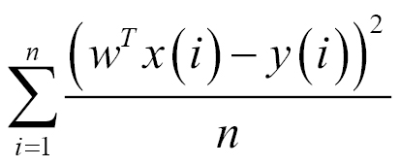

It can be calculated by taking the sum over all the data points and calculating the square difference between the forecasted and the past values.

**Mean Absolute Error :**

Another metric to asses the quality of the model is MAE in this we take the average of all absolute error and

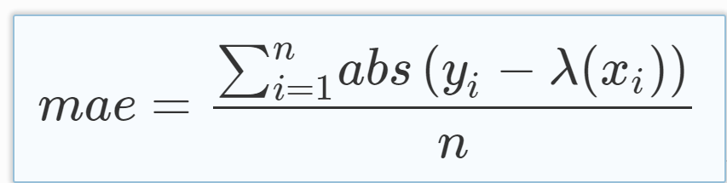

## Types of models

We have used a variety of Deep Learning Models in our research and we have obtained variety of results.

### *LSTM*

TABLE I

Different Model used

|  |  |
| --- | --- |
| SNo | Models |
| 1 | LSTM |
| *2* | GRU |
| *3* | MLP |
| *4* | CNN |
| *5* | Auto-encoder |
| 6 | Sparse Auto-encoder |
| 7 | Jordan |
| *8* | ANN |

### Long Short Term Memory . it is one of the most popular for dealing with long term dependencies and it consist of 3 gates which help in memorizing previous data

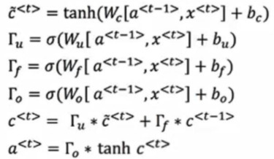

### 2) *GRU*

These type of units help in Long term Connections and also provide a lot of help in vanishing the gradient issue so it helped a lot in our research.

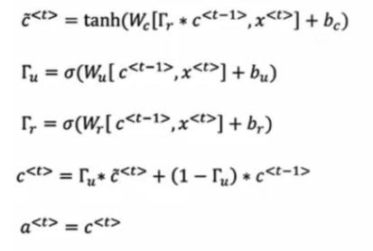

### ANN

### Artificial Neural Network is one of the most simple neural network which consist of several nodes and some output nodes with some hidden layers .it is the most basic model of Deep learning networks .

### https://cdn-images-1.medium.com/max/1250/1*hwj2OAGTW6B8wi0cVKmE4w@2x.png.

### CNN

Convolution Neural Network is a type of network in which we isolate the features of the iamge and only extract the important features of the image so that we have to process a less number of parameters and not all the features should be extracted.

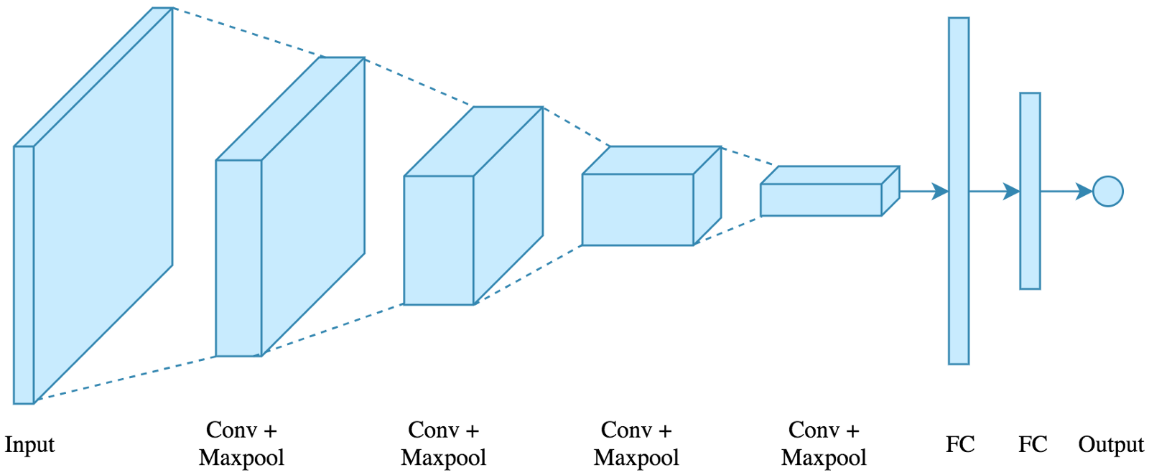

Picture:Towards Data Science

5.) Auto encoder

In this type of neural network we try to predict the output as similar to that of input as autoencoders are used for minimizing dimensions and extracting out the features

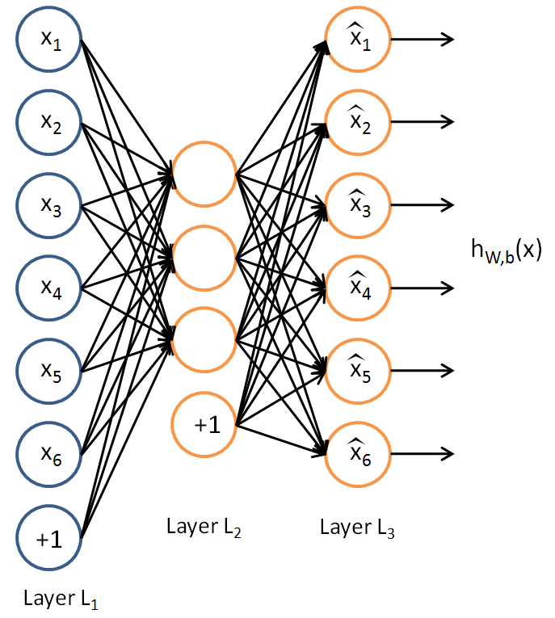

# Experimental Results

IV.I DATASET DESCRIPTION:

Gathering Datasets

For data generation various non-linear Dynamical system have been taken into consideration. Mainly those were:

Rossler

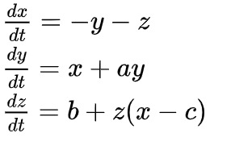

**Mackey Glass**

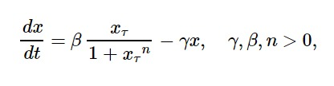

With known initial values the total length of the resulting discrete time series for each type of dynamical system is 12,001 data points.Two types of approach have been taken into consideration for using these data points as input variables to the neural network:

Embedding Dimension

Percentage Change

Embedding Dimension:-

Taking Embedding Theorem as a Reference which states that any scalar sequence *y(t1), y(t2),…, y(ti), …, y(tn*) being derived from any Dynamic System contain all the information to reconstruct the state space x. Taking  embedding dimension

As m with time delay as tau there should exists a function f such that



For the research purpose size of embedding dimension and time delay is taken to be 20 and 1 respectively and these 20 values are then feeded into the neural network in a rolling wind fashion.

Percentage Change:-

In this approach the entire dataset converted into one dimensional to seven dimensional

Where the ith column of the dataset represents the precentage change with the ith day. [3]

IV.II EVALUATION:

The prediction of time series data using neural networks can be evaluated using the 2 loss methods stated above so we have used different models to calucalte the loss and provide some results using these models :-

Initially we used ANN the most simple model of neural networks that contains an input and output node and some hidden layers but ANN does not provide a good result as it was not able to predict the forcasting values very well as due to its simplicity it was only possible to get a loss of around 0.005 (for 20 epochs) The following graphs fig 1 and fig 2 shows the variation of loss versus epoch for mckglass and roosler trained on ANN

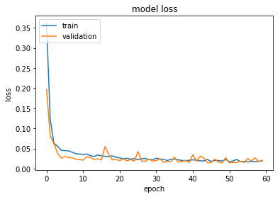

Fig 1 MckGlass with mae over ANN

As we can see from the figure the loss for approx. 20 epochs is 0.005 and the equation used here is mckglass with metric parameter used ‘mae’ so after this ANN was applied on rossler and we got a kind of similar result as shown in fig 2.

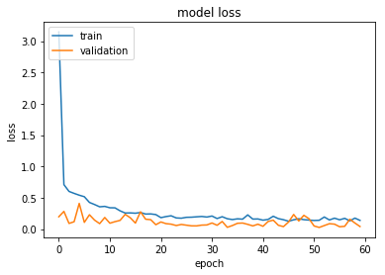

Fig 2 Rossler with mae over ANN

In the following graph rossler equation has been used with ANN neural network and from the graph (fig-2) it is evedent that a loss of around 0.005 is present for a set of 20 epochs

Now we used the CNN which is in general used for isolating features of the image, but as we have taken time series data we have to to use a 1D matrix so that we were able to use the Conv1D layer and apply MaxPolling and Fllattening to these layers and as CNN isoloate some features therefore they produced a good result than ANN with a loss of 0.003 (for 20 epochs) as shown in fig3 and fig4.

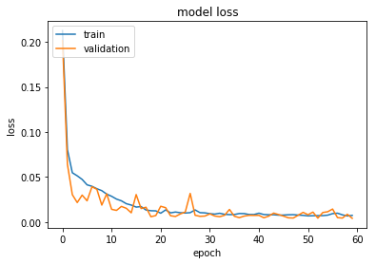

Fig 3 Mckglass with mae over CNN

This figure depicts the mae when the mckglass model is applied to CNN model and from this graph we can see the approx. change in loss is around 0.03

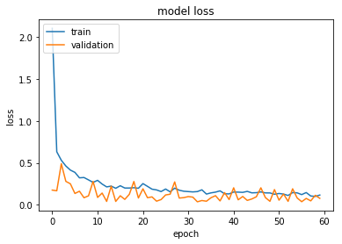

Then we used RNN as we can see our data is sequential and contains different sequence of input and output so the concept of RNN helped a lot , RNN uses 2 approaches that are LSTM and GRU , LSTM provides a much better result than GRU and other neural network models so the choice of model for time series prediction

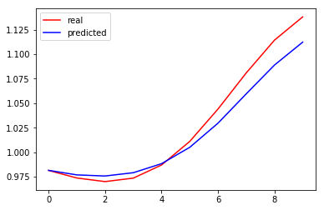

Auto encoder was also used to minimize the error and to provide appropriate result with less amount of data

Auto encoder can be of several types sparse and denoiding auto encoder and in noral auto encoder we can have a ,more number of nodes than input nodes

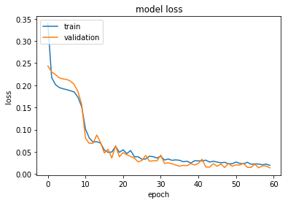

For the 2 data set wehave used similar models and calculated the losses in the similar fashion as done here

Initially we used ANN the most simple model of neural networks that contains a input and output node and some hidden layers but ann does not provide a good result as it was not able to predict the forcasting values .

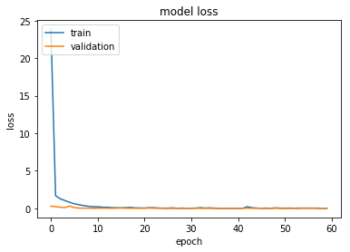

Secondly we used the CNN which is generally used for isolating features of the image but as we have taken time series data we have to to use a 1D matrix so that we were

able to use the Conv1D layer and applying MaxPolling and Fllattening to these layers and we achieved a far much result than ANN



Then we used RNN as we can see our data is sequential and contains different sequence of input and output so the concept of RNN helped a lot , RNN uses 2 approaches that are LSTM and GRU , LSTM provides a much better result than GRU and other neural network models so the choice of model for time series prediction

References

1.Predicting Chaotic Time Series using Machine Learning Techniques Henry Maathuis∗ , Luuk Boulogne∗ , Marco Wiering, and Alef Sterk

2.. The Role of the Embedding Dimension and Time Delay in Time Series Forecasting

Author links open overlay pane

l[MassimoCamplani* BarbaraCannas](https://www.sciencedirect.com/science/article/pii/S1474667015367859)

3. The Role of the Embedding Dimension and Time Delay in Time Series Forecasting Massimo Camplani*. Barbara Cannas.*

4Multivariate Chaotic Time Series Prediction Using a Wavelet Diagonal Echo State Network

5.Multivariate Chaotic Time Series Prediction Based on NARX Neural Networks Yan Xiu* and Wei Zhang School of science, Tianjin Chengjian University, Tianj

1.